

# P.F Lab 08: Switch Statement

Course Name: BSCS

Submitted by**:- Muneeb Ahmed**

Roll no:- **2430-0206**

# Submitted to: Sir. Bilal Dar

Submitted on:- 15-11-2024

**Task 1: Day of the Week**

* Write a program that takes an integer (1-7) from the user and prints the corresponding day of the week using a switch statement.
* Example input: 3
* Expected output: "Wednesday"

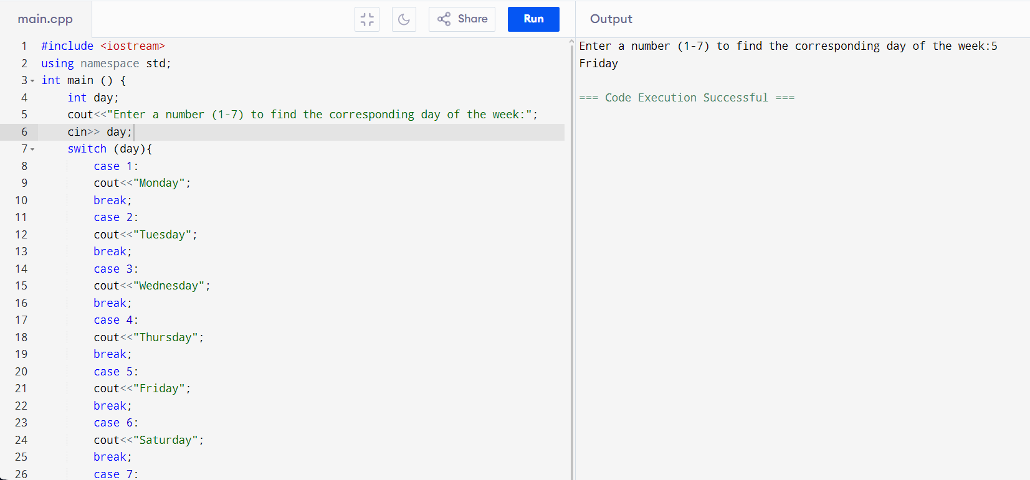 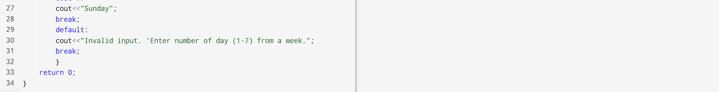

**Task 2: Simple Calculator**

* Write a simple calculator program that asks the user to enter two numbers and an operator (+, -, *, /), then performs the chosen operation.
* Use a switch statement to handle the operations and print the result.
* Example input: 5, 3, *
* Expected output: "5 * 3 = 15"

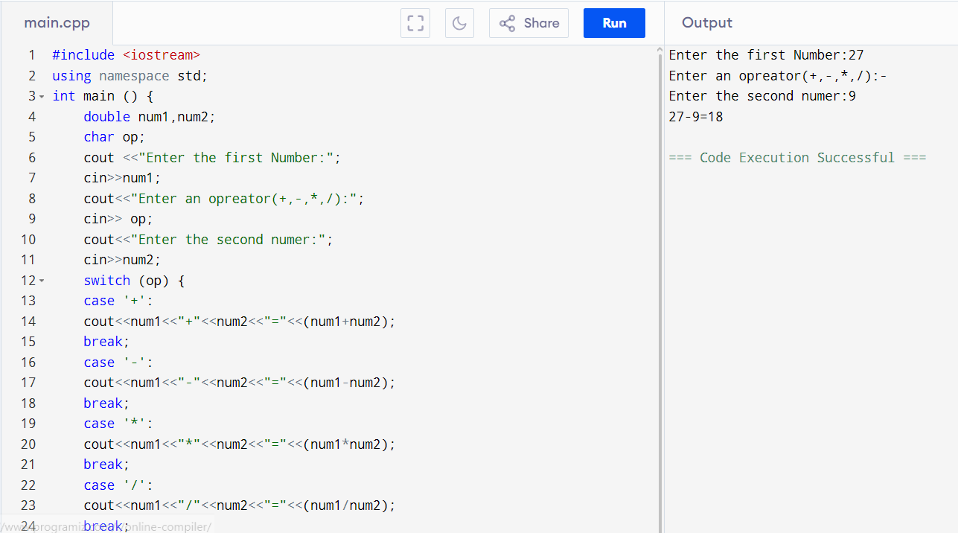 

**Task 3: Vowel or Consonant**

* Write a program that asks the user for a single alphabet character and uses a switch statement to check if it’s a vowel or a consonant. The program should work for both uppercase and lowercase letters.
* Example input: 'a'
* Expected output: "a is a vowel"

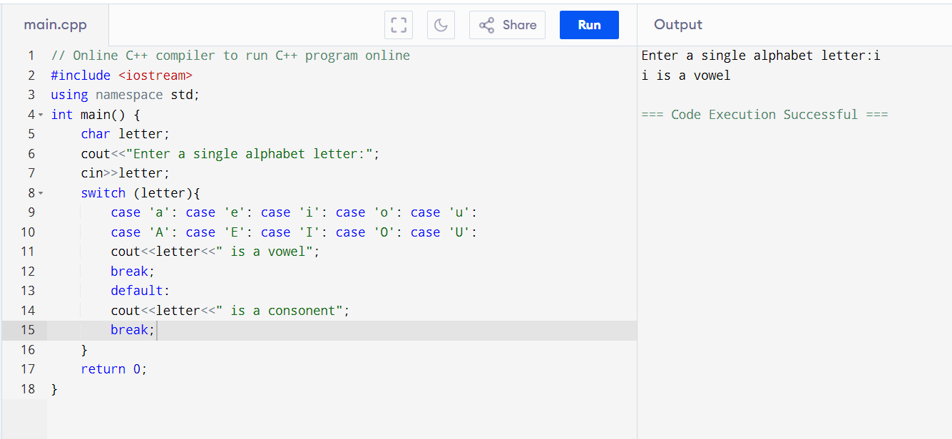

**Task 4: Grade Converter**

* Write a program that takes a letter grade (A, B, C, D, or F) and outputs a description of the grade. For example, A means "Excellent," B means "Good," etc.
* Example input: B
* Expected output: "Good"

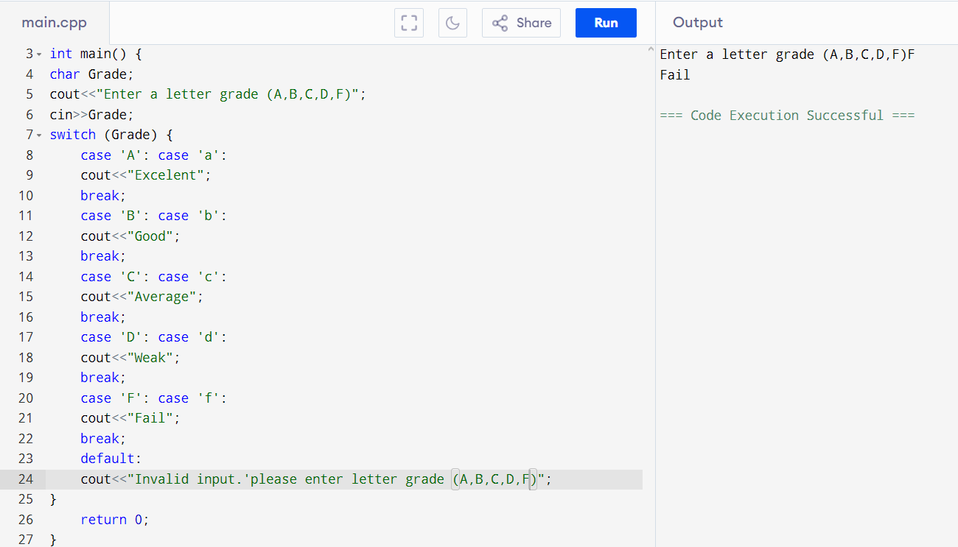

#### **Task 5: Simple Bank Transaction System**

Write a program that simulates a basic bank system with a switch menu to deposit, withdraw, or check balance.

**Requirements:**

* Display a menu:
  1. Deposit
  2. Withdraw
  3. Check Balance
  4. Exit
* Ask the user to choose an option and use a switch statement to perform the selected task.
* Keep track of the balance and ensure the withdrawal doesn’t exceed it. 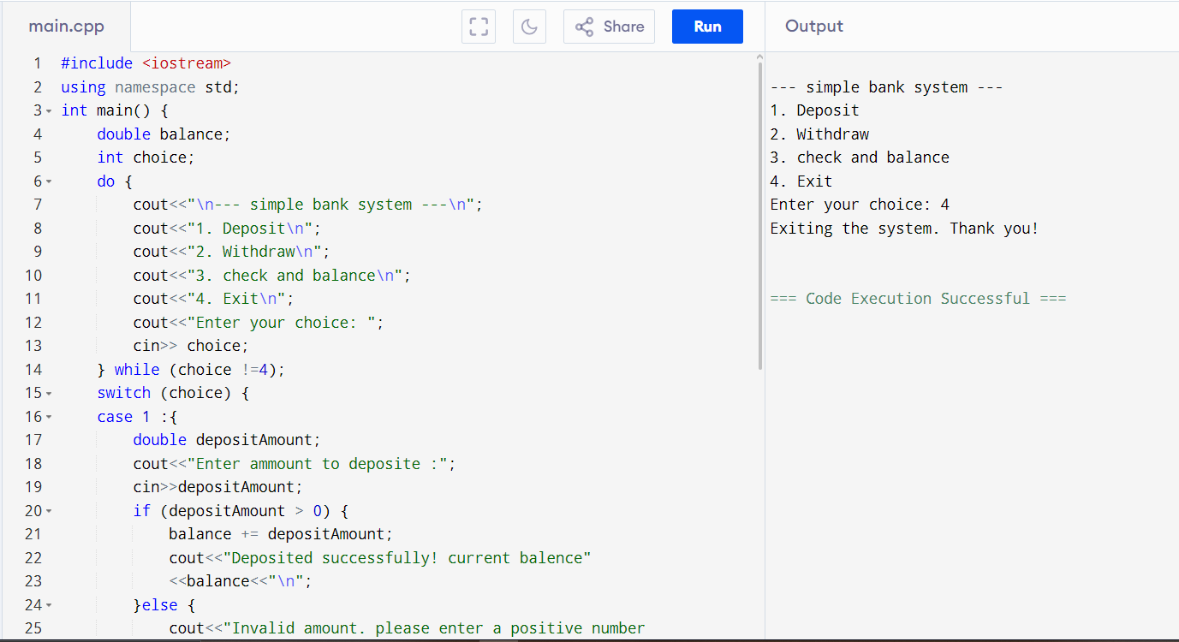

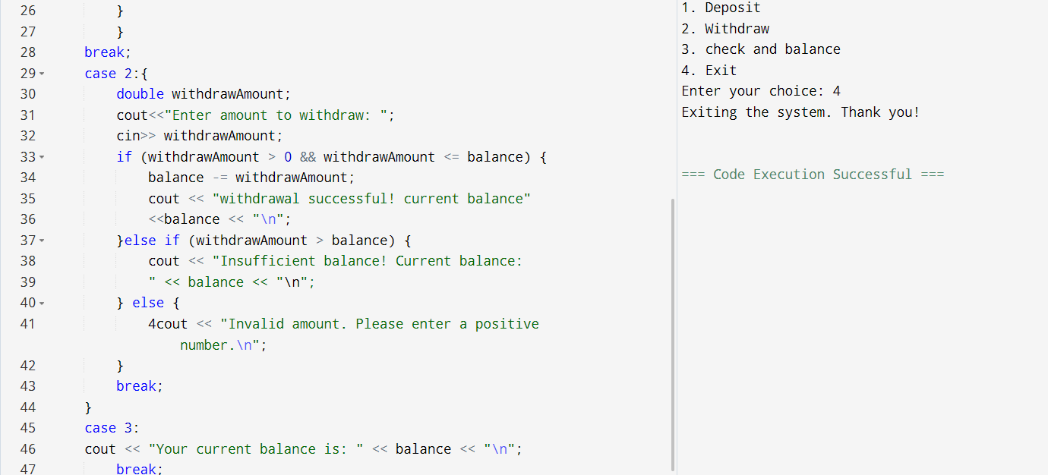 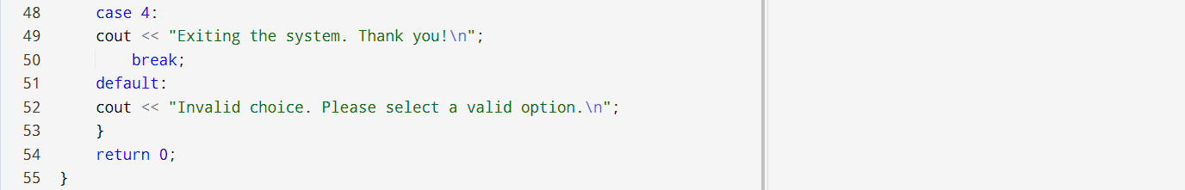

#### **Task 6: Simple Traffic Light Simulation**

Write a program that simulates a traffic light system. The user enters a color (R, G, Y for red, green, yellow), and the program gives an action.

**Requirements:**

* R: "Stop"
* G: "Go"
* Y: "Slow down"
* Use switch to handle each case and print the appropriate message.

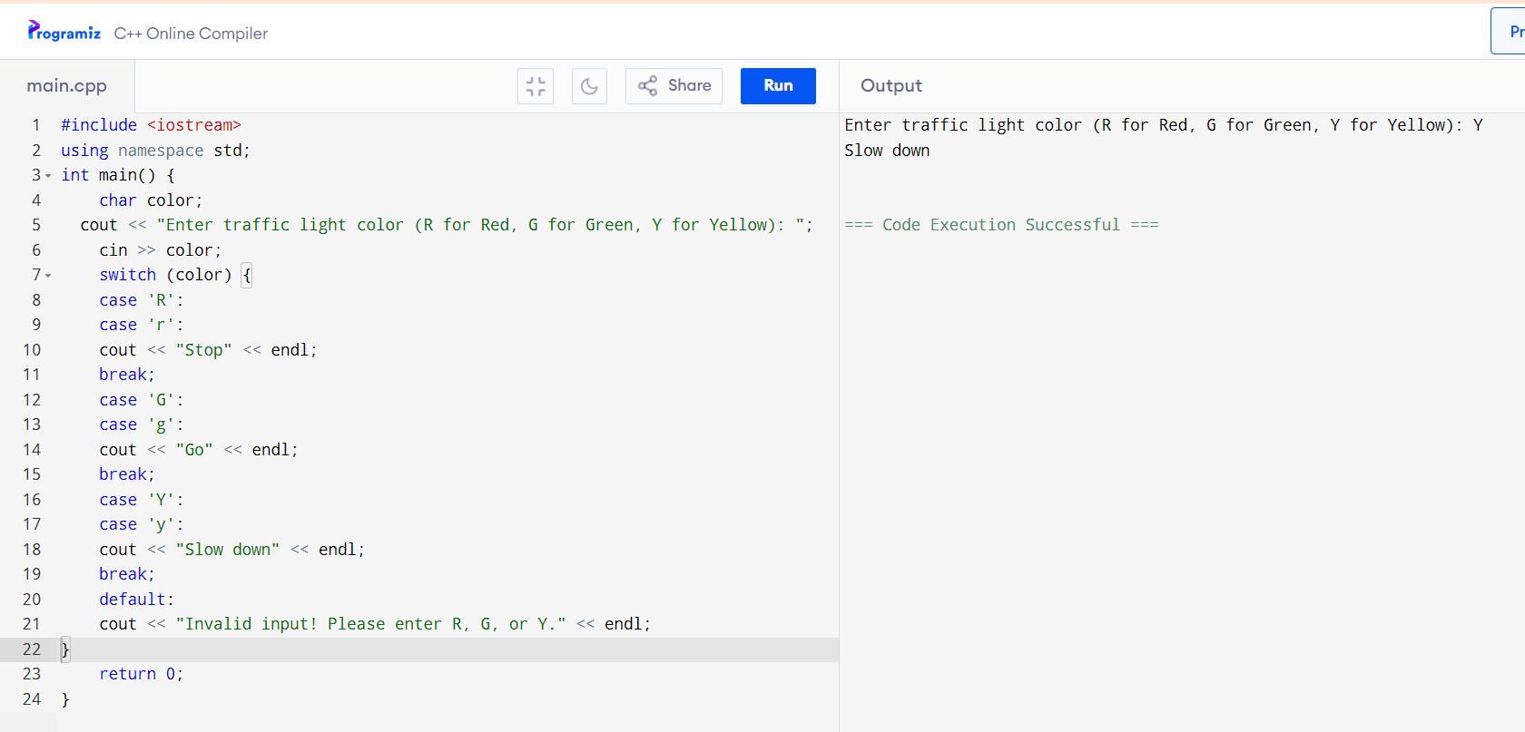

**Task 7:**

Write a program that takes an integer (1 to 12) representing a month and uses a switch statement to print the corresponding season (e.g., December, January, and February print "Winter").

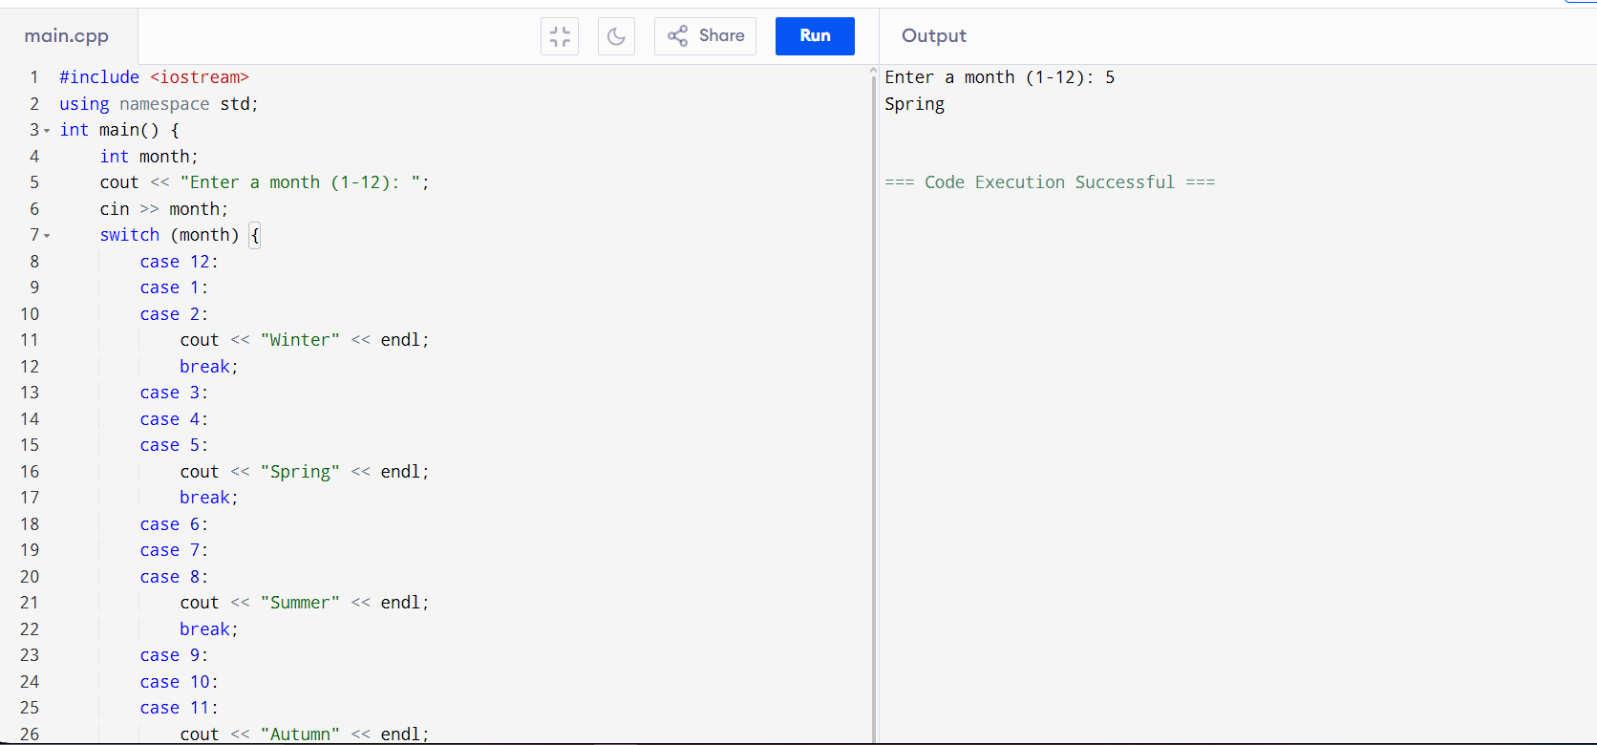 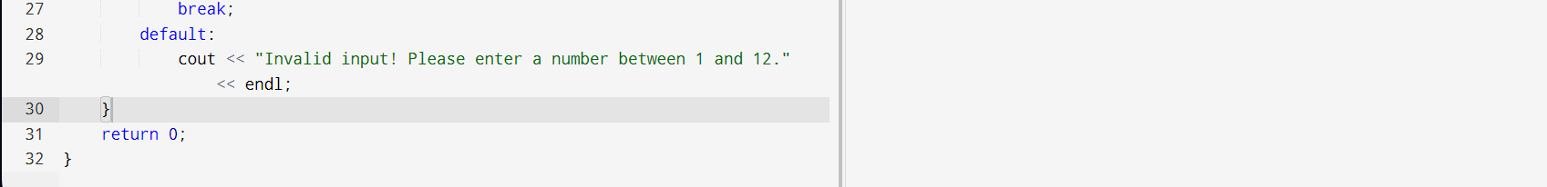

**Task 8:**

**Number to Words**: Write a program that takes a single-digit integer (0 to 9) as input and uses a switch statement to print the corresponding word (e.g., 0 should print "zero").

